Project Title

Contact Manager Backend Application

Project Overview

The Contact Manager is a backend web application developed using Node.js, Express.js, and MongoDB. It allows users to register, log in, and manage their contacts. Users can create, update, delete, and search contacts easily. The system provides secure authentication and ensures that each user can manage their own contacts.

Tools and Technologies Used

Tools and Technologies Used
Node.js – Backend runtime environment
Express.js – Web framework for API development
MongoDB – NoSQL database
Mongoose – MongoDB object modeling tool
Thunder Client – API testing tool
Visual Studio Code – Code editor
Backend Development
The backend server is built using Express.js. It is configured with middleware to handle API requests efficiently, including CORS and JSON parsing.
Example:
JavaScript
Copy code
App.use(express.json());
App.use(cors());

User Authentication
The application provides secure user authentication with the following features:
User Registration
User Login
Password Hashing using bcrypt
Token Generation using JWT

API Routes
Different routes are implemented to handle specific operations:
Route
Description
/api/auth/register
Register a new user
/api/auth/login
Login for existing users
/api/contacts
Create, read, update, delete, and search contacts
These routes handle HTTP requests and interact with the MongoDB database.
Data Models
User Model
Name
Email
Password
Contact Model
userId
Name
Email
Phone
Notes
Tags

CRUD Operations
The application supports the following operations on contacts:
Create Contact
Read Contact
Update Contact
Delete Contact
Search contact
Database Configuration

The application connects to MongoDB using Mongoose.
Example:
JavaScript
Copy code
Mongoose.connect(MONGO_URI, {
useNewUrlParser: true,
useUnifiedTopology: true
});
API Testing

All APIs are tested using Thunder Client in Visual Stud
APIs tested:(Screenshots)
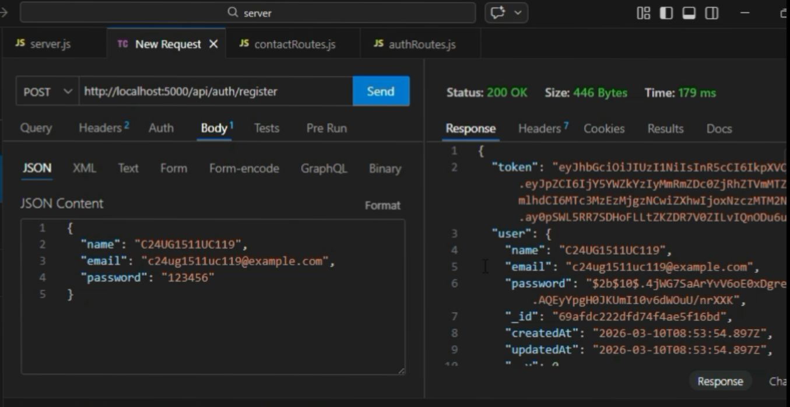
Register API

Login API
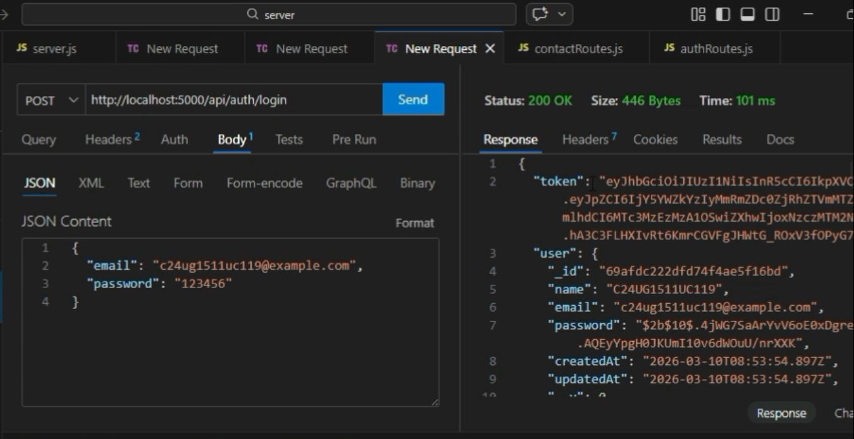

Add contact API
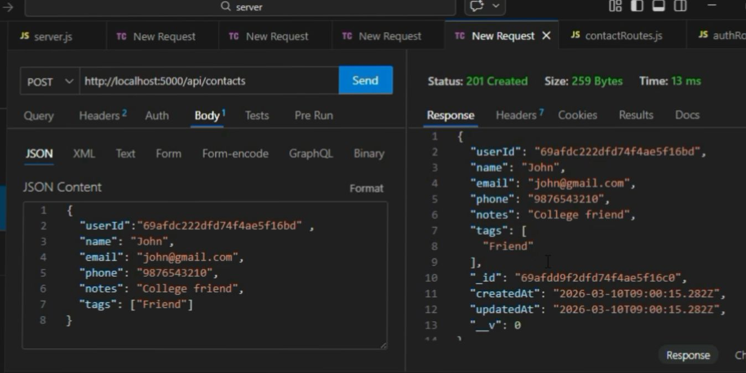

Get contact API
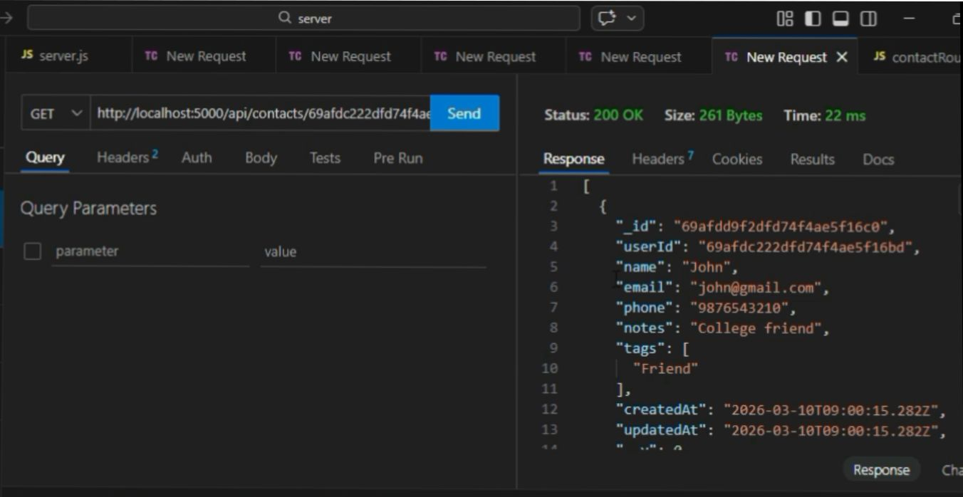

Update contact API
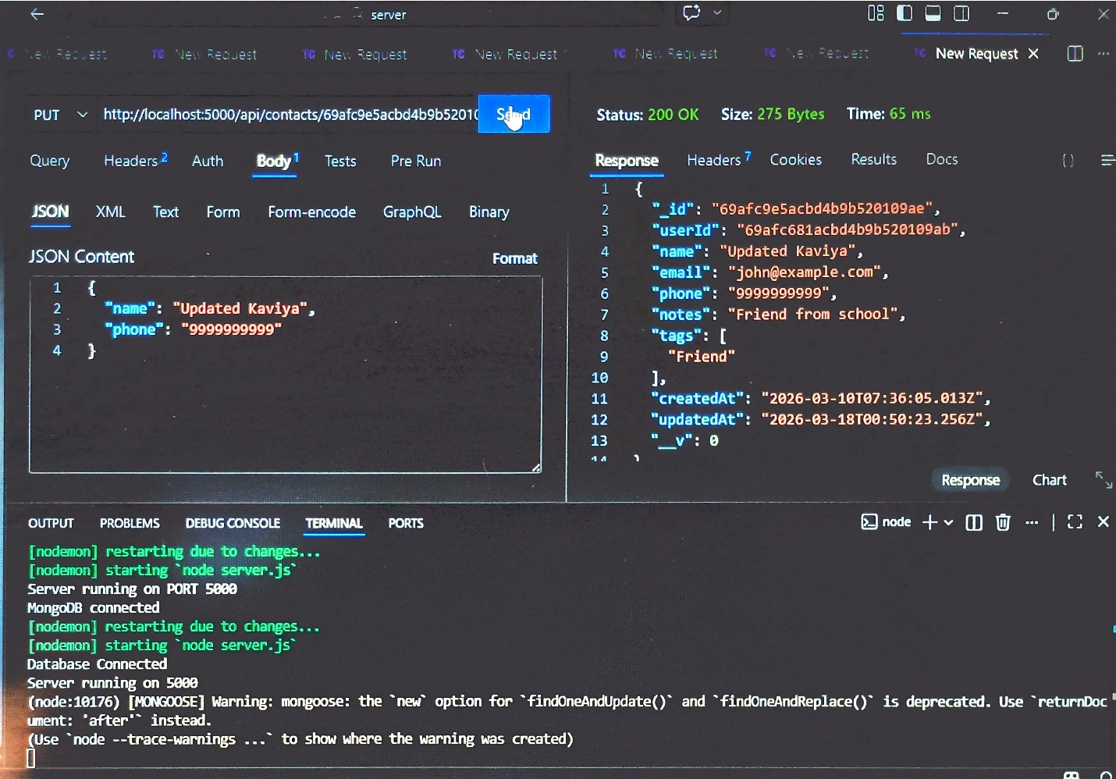

Delete contact API
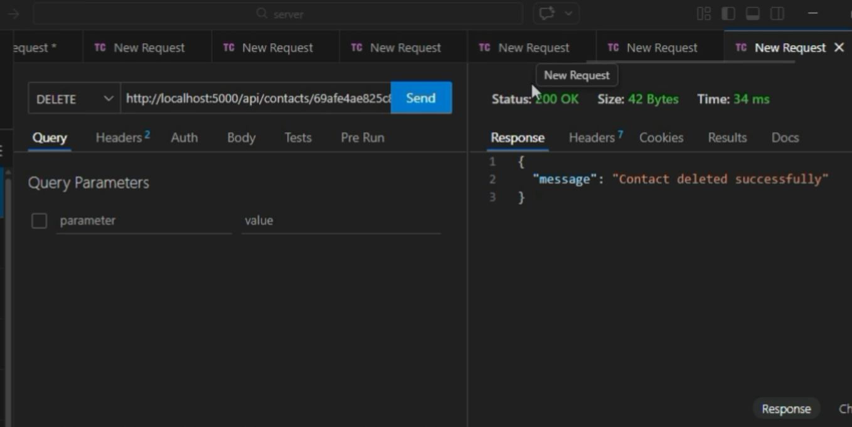

Search contact API
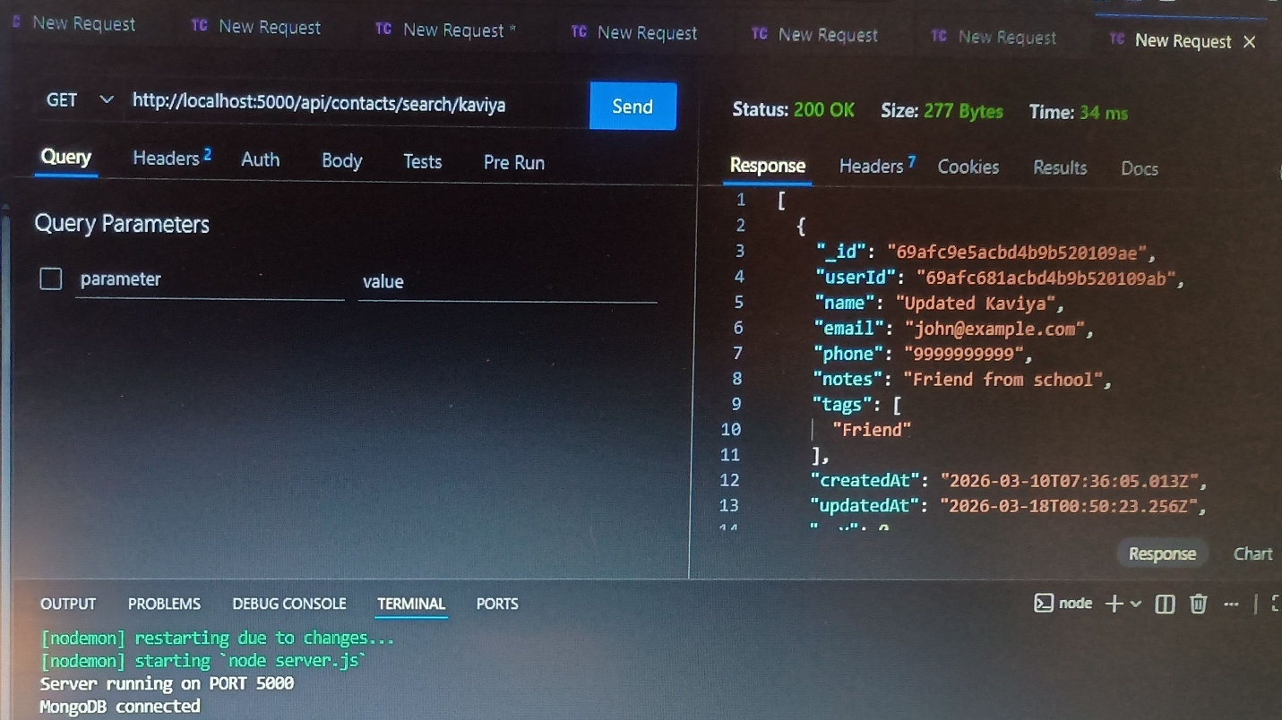

Conclusion
The Contact Manager backend application successfully provides user authentication and contact management features. This project demonstrates how Node.js, Express.js, and MongoDB can be effectively used to build RESTful APIs for real-world applications.

